- Domain____________________ 3. Domain______________________
Range_____________________ Range_______________________
Max or Min_________________ Max or Min_________________
End Behavior_______________ End Behavior___________________
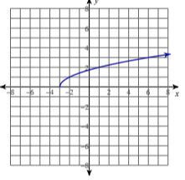
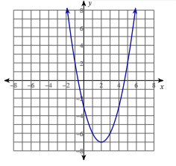
Parent Function______________ Parent Function_______________

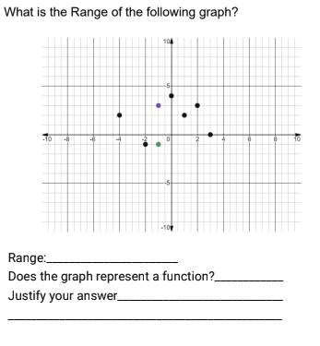
- Domain_________________ 4.
Range__________________
End Behavior____________
Max or Min______________
Parent Function_____________
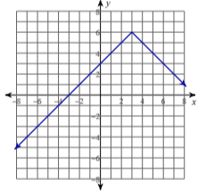

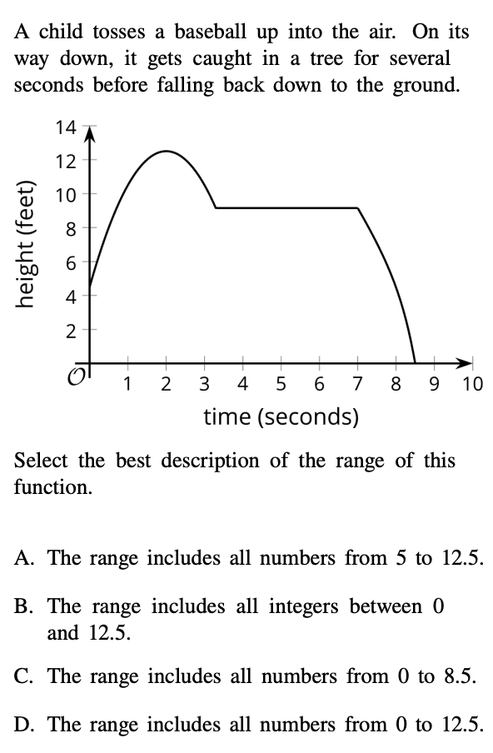
5. 6. How do the graphs of $f(x) =x$ and $g(x)=|x|$
compare?

a) $f(x)=g(x)$ for $x≥0$ b) $f(x)=g(x)$ for $x<0$
c) $f(x)=g(x)$ for $x>0$ d) $f(x)=g(x)$ for $x≤0$
e) $f(x)=g(x)$ for all values of $x$

_____________________________________________

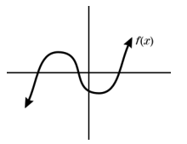
8. Use the graph of $f(x)$ to determine which statement is
false.

- The domain range of this function are equal
- The domain of $y=x^{2}$is the same as the domain of $f$
- The range of $y=|x|$ is the same as the range of $f$
- $f$ is continuous for all the real numbers
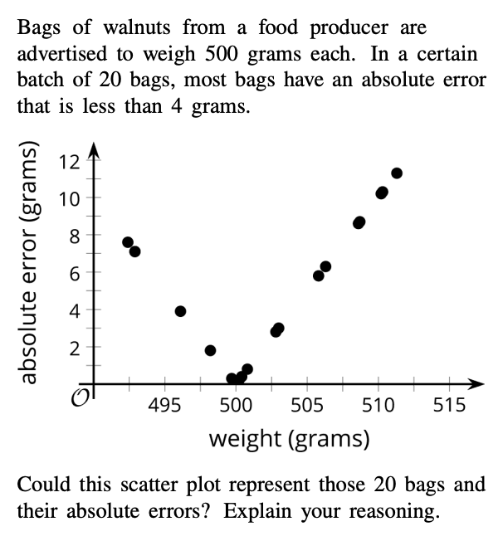
______________________________________________
7. The hang time (in seconds) for a football
that has been kicked into the air is given by 9.
is given by the function
$T(h)=\frac{\sqrt{h}}{2}$
Where $h$ represents the maximum height of the
Football. Which of the following is the most
reasonable domain for this situation?

- All real Numbers c. $[0,∞)$
- $(0,∞)$ d. $[0,60]$

_________________________________________
_________________________________________

